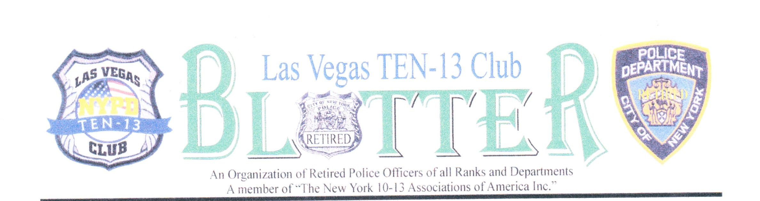

volume 1 issue 2

MAY 2021
OFFICERS
President
Charlie Licata
(702) 204-1399
Vice President
Bill Swierupski
(702) 489-2890
Treasurer
Ron Mele
(702) 467-7651
Secretary/Editor
Bill Swierupski
(702) 489-2890
Sgt. At Arms
Tom Brady
(702) 865-2851
Trustees
Pete Trimboli
Robert Shack
Alvin Fields
Gene Vitale
John Just Jr.
Chaplain
Peter Billitteri
(702) 645-9629
Past Presidents
David Solomon D
Harry Bethel D
Robert Burns D
John Just. Jr.
Peter Trimboli

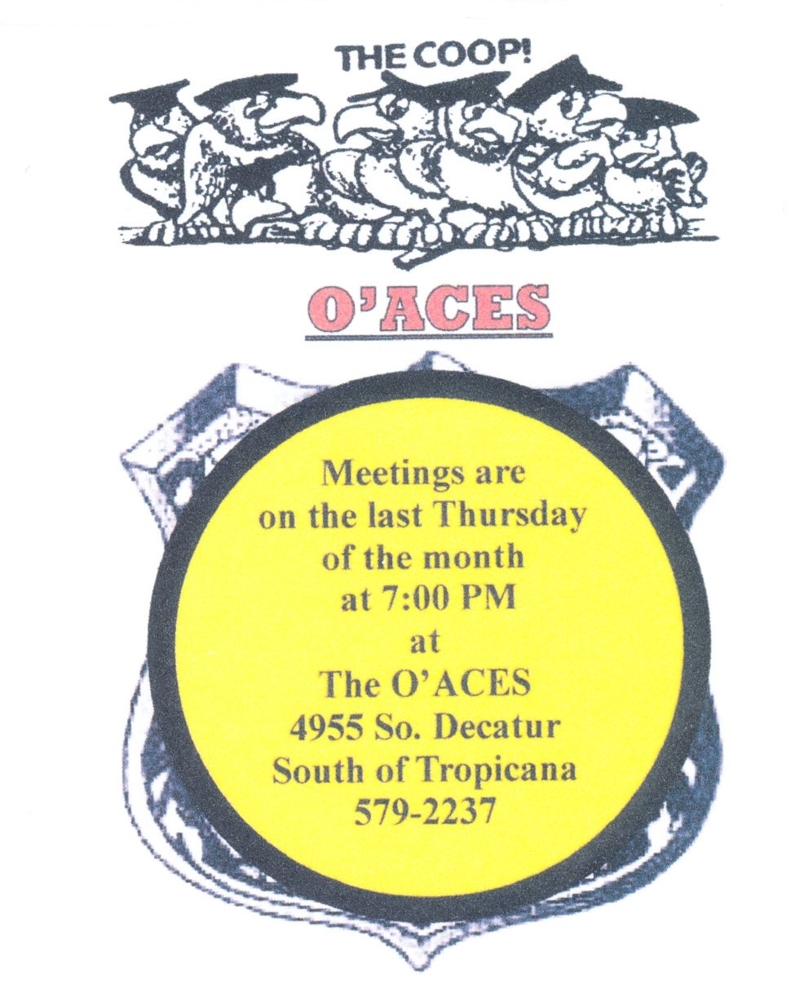
Important Phone Numbers
NYPD Operations Desk: (646) 610- 5580
Pension Section: (866) 692-7733

This column is also a great way to inform employees of big company news before it hits the TV or major newspapers.
To make this column successful, you should ask the president to be as candid and honest as possible. This is a place to inform employees, not promote a project or sell an idea.
Comptrollers Action Center: (212) 669-3916
ID Card Section: (646) 610-5150
Employee Benefits: (212) 233-5531
PBA Office: (212) 233-5533
PBA Health & Welfare: (212)349-7560

DEA Office: (587) 912-0212
DEA Health & Welfare: (212) 587-9120
SBA Office: (212) 226-2180
SBA Health & Welfare: (212) 431-6555
LBA Office: (212) 964-7500
Social Security: (800) 772-1213
GHI: (800) 358-5500 2ting Datesmpire Blue Cross: (800) 433-9592
Medicare Reimbursement: (212) 513-0470 2021 Meeting Dates
Medicare Part A: (800) 433-9592 January 28 July 29
Medicare Part B: (800) 333-7586 February 25 August 26
NYC Health Line (800) 521-9574 March 25 September 30
NYPD (DIF): (212) 374- 550 April 29 October 28
VA Benefits: (800) 827-1000 May 27 November 18
COLA Ret. System: (866) 805-0990 June 24 December: Party
Ret. Clearance Unit: (646) 610-6086 * Dues are always in order *
NYC Pension Webb Site: www.nyc.gov Payable at any meeting
Retiree Clearance Unit: (646) 610-6086 Or by check, to: LV Ten-13 Club
C/O Ron Mele
1721 Honey Tree Dr. Las Vegas, NV 8914
Las Vegas Ten-13 Club Newsletter Page 2

Birthdays, Anniversaries and Retirements

Happy Birthday to: Happy Anniversary to:
Eugene Vitale 5/12
Frank Hanratty 5/23 Joseph & Roxanna Callo Jr. 5/30/80
Tom &Karen Brady 5/29/87
Ross Abramson 5/29 Frank & Kathleen McCabe 5/29/00
Daniel Argano 5/30

Appointed on: Retired On:
Frank McCabe 5/3/65 Tom Brady 5/28/77
Joseph Ellis 5/20/85
Gene Venezia 5/00/93

JUNE, 2021
Sunday | Monday | Tuesday | Wednesday | Thursday | Friday | Saturday
 |  | 1 | 2 | 3 | 4 | 5
6 | 7 | 8 | 9  RANGE | 10 | 11 | 12
13 | 14  FLAG DAY | 15 | 16 | 17 | 18 | 19
20  FATHER’S DAY | 21  FIRST DAY OF SUMMER | 22 | 23 | 24  MEETING | 25 | 26
27 | 28 | 29 | 30
Las Vegas Ten-13 Club Newsletter Page 3

“President's Message”

The train has finally reached the end of the tunnel. Now that all Covid restrictions are beginning to be lifted, we can all start to get our lives back to normal. Masks and social distancing will soon become a thing of the past. You can start to live your life as you like it to be, once again you will enjoy a certain feeling of normalcy. For those who did not attend the annual picnic, you missed a good time. Aside from the wind that blew everything around and prevented us from setting up our new tent, it turned out to be a great time for all. There was plenty of food and drink, even enough for doggy bags to go. We held a fun raffle for bottles of wine and liquor, and nearly everyone won a bottle. A special thanks to all who worked their tails off setting up, serving, and cleaning up. Mayor pro-temp Stavros Anthony attended and said a few words to the group and presented us with a certificate and plaque. He has always supported our club and I hope one day we can support him. Due to unforeseen circumstances, we were unable to hold our annual raffle for the $1,000, so it will be held at our May meeting. Councilwoman Victoria Seaman will attend our May meeting to update us on the plans for 9/11 and she will also draw the names of the raffle winners. I am asking all members to please try to attend our May meeting as we will be discussing all our needs for the 9/11 memorial event. Until we meet again, live every day as if it were your last day, because one day it will be.

Fraternally,
Charlie Licata

Minutes of the MAY Meeting.
Meeting called to order at: 7:30 By: President Licata
Pledge of Allegiance led by: Sergeant-at-Arms Tom Brady
Moment of Silence for departed members & Prayer: Peter Billitteri
Number of members present: 17

Las Vegas Ten-13 Newsletter Page 4

Presidents Report: The 9/11 commemorative pins are in, cost $5 each. Also have plenty of shirts and hats as well, it would be nice if everyone of us attending the 20th 9/11 ceremony this year be wearing a Club shirt. The board met with Councilwoman Victoria Seaman and her staff to discuss our needs for the 9/11 event. They were very receptive and want to co-host with us. Working with them, we were promised a stage, honor guard, bagpipes, bugler, media coverage, as well as them reaching out to the various Police and Fire departments in the area for representation. We are also hoping to have the Pahrump Volunteer Fire Department send us the Fire Engine they received and refurbished from the FDNY which was present on 9/11. We will need plenty of help that day so we will be setting up various committees volunteer assistants to handle the different details.
If anyone needs their I.D. Card renewed, give it to me and I will send it to our NY contact, who will in turn get it renewed and then mail it back to me, he will only deal with the Club president.
Vice Presidents Report: No report
Treasurer’s Report: Dues are in order for 2021. $4,835 on hand in Bank account.
Secretary’s Report: If any member has any information, they would like placed into the newsletter, please let me know.
Trustee’s Report: No Report
Old Business:
New Business: Former Vice President Bob Moran who recently moved to Florida, will now be our Club’s representative to the National 10-13 Association, which is based in Florida. He will forward all relevant information from them to us.

Las Vegas Ten-13 Newsletter Page 5

Raffles: Raffle ticket money being turned in, final Club receipts and net will be known after the drawing.
RANGE: We shoot at the range on the 2nd Wednesday of every month, at 11am. The next shooting date will be on June 9th at 11am at the Green Valley Range, 176 Cassia Way, Henderson. You can also qualify for your HR-218 there. They may offer free gun cleaning, covid restrictions notwithstanding. If they do, a tip would be a nice gesture.

Th.
GOOD & WELFARE: April meeting 50/50 winner was Charlie Licata, who generously donated his winnings back to the club. The receipts of the evening were $750, taken in through dues payments, raffle money, 50/50 donations, and sale of hats, shirts, and pins.
SICK & DISTRESSED: Bob shack has been in the hospital with some medical problems. If anyone knows of a sick member, please give that information to the Board.
Committee Reports
Christmas Party: No Report
Picnic:
Meeting Adjourned at: 8:00pm

NEXT MEETING MAY 27th
Member’s News:

LIKE US ON FACE BOOK: LASVEGASTEN-13
CLUB WEB SITE: LVNYPDTEN-13.COM

*RETIRED POLICE ASSOCATION OF THE STATE OF NEW YORK*
FYI: This organization has been around a very long time and one of many that look out for all retirees. If you are interested their web site is, retiredpoliceassociationofnewyork.com, and download their app. Their dues are very reasonable, and they have very good info.

Las Vegas Ten-13 Newsletter Page 6
Business’s that are friendly to our members

Mention you are a member of the Ten-13 Club

Automotive repair

Best Muffler Shop
33 N. 21st Street, Las Vegas. 702-385-1934, 702-1935
Ask for Dan (Owner) or Phil (Mechanic)
Chiropractor

CRIMSON CANYON CHIROPRACTIC
Dr. Roger M. Penna
2670 Crimson Canyon Drive, Suite 150
(702) 232-3189

Dental Work
FLAMINGO SMILES DENTISTRY 9516 W. Flamingo Rd. suite 20D Las Vegas, NV 89147
Dr. Sandra Lee
(702) 254-3135
Advanced Dental 7435 Eastern Ave. Las Vegas, NV89123 Tinh Ho, DDS (702) 405-2381
Food
John Mulls Meats Butcher / Road Kill Grill Restaurant & Catering 3730 Thom Blvd. Las Vegas, NV 89130 (702) 645-1200

